**Personal reflections and insights**

1. **Project Motivation and Goals**

As an anime fan, I have been influenced by Japanese anime culture since I was a child. I even often imagine myself as a character in "Naruto". I use anime characters as my social profile pictures, but there is a problem. My appearance is not similar to the anime characters I like, and I hope my avatar will be in the style of Naruto. Out of my passion for art and technology, I hope to use technology to generate some anime avatars of my own. For example, using neural networks to transform images and imitate artistic styles.

In this project, I will create a powerful style transfer model. My main goal is to develop a CycleGAN model that can effectively transfer styles between different fields. As shown in the figure below, the 1st, 3rd, and 5th are real people's portraits, and the model can input the corresponding anime style portraits based on the real input portraits.

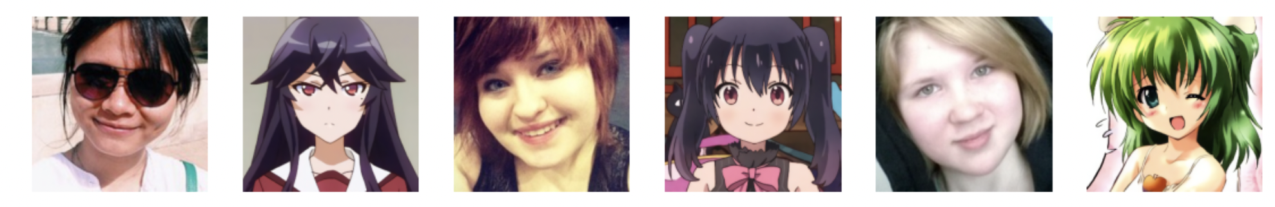

I want to create visually stunning results that can generate anime-style avatars and show the power of artificial intelligence in the creative process. At the same time, the CycleGAN model is not limited to the conversion of anime styles. In the future, we can also try various artistic styles and how to apply them to different image datasets. This exploration may lead to innovative applications in fields such as graphic design, fashion, and entertainment.

1. **Overall Experience**

Due to my lack of deep learning experience, working on this CycleGAN project was a long journey, and I experienced too many surprises and failures. For a beginner like me, this project was a huge challenge for me, and I even tried to give up, but every time I watched my favorite anime again, I would start my project again. At the beginning, I didn't know CycleGAN , and I didn't know which model to choose to train our data. So I asked Chat GPT to be my mentor for this project, and according to Chat GPT 's advice, I finally decided on CycleGAN as the prediction model. CycleGAN is a special kind of generative adversarial network (GAN) that learns the conversion between images through two competing generators and discriminators without paired training data. This model can be used for a variety of image conversion tasks, such as style transfer, image translation, and image enhancement.

CycleGAN lies in its cycle consistency loss function, which enables the model to perform style transfer while maintaining the content of the image. For example, it can convert a summer photo to a winter look, or convert an image of a horse to an image of a zebra. Therefore, I think CycleGAN is also very suitable for my project.

I learned a lot in this project. The first is that data quality is very important. I think data quality determines the upper limit of model performance. Having a diverse and well-structured dataset can have a significant impact on the training results. Initially, I used a smaller dataset and the results were not satisfactory. Expanding the dataset really helped improve the performance of the model. Since my project was finally open source, the project was highly iterative and I tried to make my code "elegant" and easy to understand. I found that I needed to go back to the drawing board frequently - revisit my code, adjust the architecture, and even rethink my training methods. I tried my best to make it easy for other researchers to understand my work, even to adjust my code, such as some hyperparameters for model training. Therefore, I learned how to standardize the training code, use the argparse framework to assist in parameter input, and even set default values for training parameters. In the figure below, you can see how the model is trained and how the model transfers the style from one image domain to another. It is fascinating to observe the different styles captured in the output!

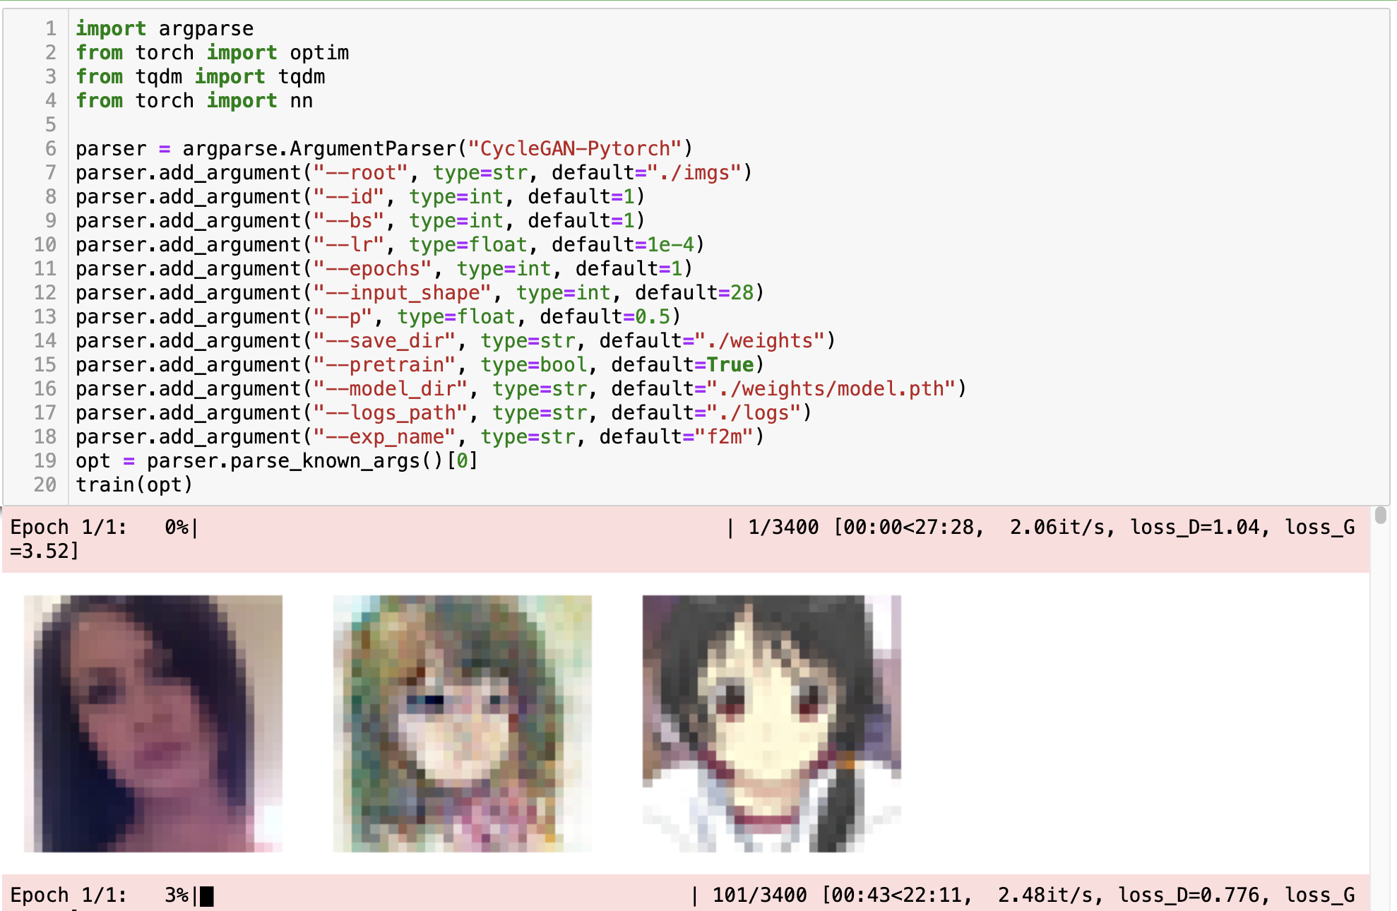

During the training process, I often felt frustrated. I encountered challenges with model convergence and debugging, and I even doubted whether the model I chose was the right one. I spent hours adjusting hyperparameters, trying to figure out why my loss was not improving. But overcoming these obstacles only made me feel more accomplished.

1. **Future Work**

I chose the CycleGAN project because of my love for art and technology . I hope to create a powerful model to demonstrate the potential of artificial intelligence in art and explore new artistic possibilities . In the future, I will also use this model to explore new discoveries in other datasets and even explore the technology of generating images from text.

**References**

[1] Kayed , AW, 2024. Generating Anime using StyleGAN .

[2] Ahmed, MI, Hasan, MR, Uddin, KMI and Khan, R., 2023, April. Photo-to-Cartoon Translation with Generative Adversarial Network. In 2023 7th International Conference on Trends in Electronics and Informatics (ICOEI) ( pp. 265-269). IEEE.

[3] Deng, S., Uchida, K. and Yin, Z., 2021, November. Cross-modal and Semantics-Augmented Asymmetric CycleGAN for Data-Imbalanced Anime Style Face Translation. In Proceedings of the 2021 3rd International Conference on Video , Signal and Image Processing (pp. 43-51).

[4] Huang, LC and Tsai, HH, 2023. Perceptual Contrastive Generative Adversarial Network based on image warping for unsupervised image-to-image translation. Neural Networks, 166, pp.313-325.